

**COLLEGE OF COMPUTING, INFORMATICS AND MATHEMATICS**

**UNIVERSITI TEKNOLOGI MARA**

**MERBOK, KEDAH**

**DIPLOMA IN LIBRARY INFORMATICS**

**(IM144)**

**PROGRAMMING FOR LIBRARIES**

**(IML208)**

**PROJECT NAME: STORE INVENTORY SYSTEM**

**PREPARED BY:**

**ANIS SYAZWANI BINTI ROZAINI**

**GROUP: CDIM1443D**

**PREPARED FOR:**

**SIR MOHD FIRDAUS BIN MOHD HELMI**

**SUBMISSION DATE: 12th DECEMBER 2023**

**PROJECT NAME:** Stationery Store Inventory System

**FILE NAME:** inventory.py

**PROMPT DATA:**

1. **ID:** for the item Id
2. **Name:** name of the item
3. **Price:** the cost for one item
4. **Quantity**: how many items of one product

**FUNCTION**

1. **CREATE** data
2. **READ** data
3. **UPDATE** data
4. **DELETE** data

**CONDITIONAL STATEMENT:** YES

If-else statement

if itemId == ""or itemId ==" ":

        print("Error Inserting Id")

    if itemName == ""or itemName ==" ":

        print("Error Inserting Name")

    if itemPrice == ""or itemPrice ==" ":

        print("Error Inserting Price")

    if itemQuantity == ""or itemQuantity ==" ":

        print("Error Inserting Quantity")

    else:

        insert(str(itemId),str(itemName),str(itemPrice),str(itemQuantity))

**GUI**: YES

**RESULT:**

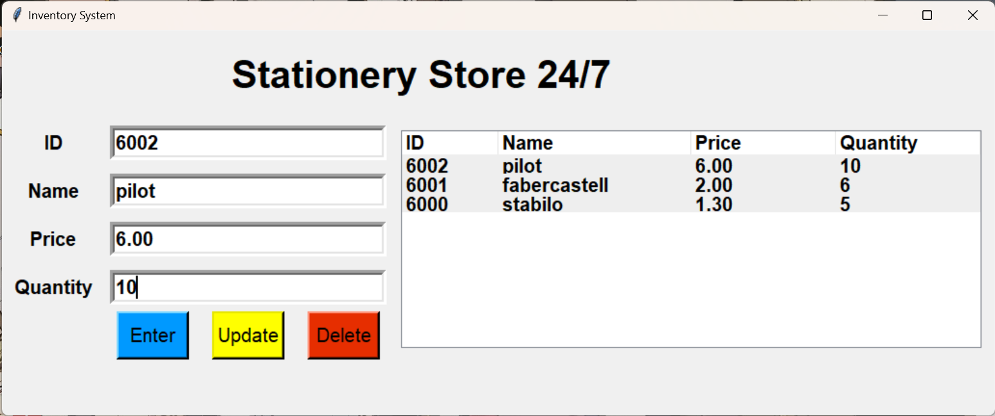

**STRENGTH:**

* **User-Friendly Interface:** The graphical user interface (GUI) built with Tkinter allows users to interact with the inventory system in a simple and user-friendly manner.
* **Basic CRUD Operations:** Users can insert, view, update, and delete inventory items using the system's basic CRUD (Create, Read, Update, Delete) operations.
* **SQLite Database Integration:** Using a SQLite database to store data is appropriate for small-scale applications. SQLite is a lightweight database that is simple to set up and configure.
* **Treeview for Data Display:** The Tkinter library's Treeview widget is used to display inventory data in a tabular format, allowing users to easily view and manage the data.
* **Error Handling:** Some basic error handling is included in the code, such as checking for empty or whitespace input when inserting data.
* Can list all the items available.
* Able to check the current prices of an item.
* The quantity left on the shelves and the quantity restocked.

**KAIZEN (ROOM FOR IMPROVEMENT):**

* **Validation of Input:** Increase the strength of input validation to ensure that only valid data is entered. Examine the data types, numerical ranges, and lengths.
* **Modularity and structure of the code:** Divide the code into modular functions with distinct responsibilities. This makes the code more maintainable and understandable.
* **User Reactions:** Provide informative messages or alerts for successful and unsuccessful operations to improve user feedback. Think about using pop-up messages or status bars.
* **Security Procedures:** Implement basic security measures such as input sanitization and SQL injection protection. Consider using parameterized queries for database operations rather than string concatenation.
* **Logging:** Implement logging to keep track of important system events, errors, and changes. This can help with system debugging and monitoring.
* **Dialogs for Confirmation:** Before performing critical operations such as deletion or updates, add confirmation dialogs. This can aid in the prevention of unintentional data loss.